 | American International University- Bangladesh (AIUB)  Faculty of Engineering (EEE)
Course Name: |  | Electronic Devices Lab.
Semester: |  | Spring 2021-2022 |  |  |  | Sec: | W
Course Code: |  | EEE 2104 |  |  |  | Course Teacher: | Mehedi Azad Shawon
Student Name: |  | LEO, NAFINUR |  |  | Student ID: |  | 20-42195-1
 |  | HOWLADER, MD. SHAKIB |  |  |  |  | 20-42752-1
 |  | FAHIM, SHAH NAWAJ |  |  |  |  | 20-42794-1
 |  | RAHMAN, HASIBUR |  |  |  |  | 20-42853-1
 |  | HASAN, MD. ALIF |  |  |  |  | 20-42870-1
Submission Date: |  | 17-04-2022 |  |  | Deadline: |  | 17-04-2022
Assessed POI |  |  | P.d.2.C4
CO1 |  |  | Analyse and justify the collected data to reach substantiated conclusion such as performance of amplifier circuits recognizing the constrains.

Marking Rubrics will be followed as below. (to be filled by the Faculty)
Objectives | Proficient  [5-4] | Good  [3] | Acceptable  [2-1] |  | Secured Marks
Data validity | All data was complete and accurately labeled. Identified and described trends and made appropriate conclusions based on the data. Used simulation techniques to identify and analysis with appropriate calculations. | Most of the data was complete and accurately labeled. Simulation was done appropriately. Simulated date. | Data was incomplete. There is no simulation or there is a big difference in simulated data.
Data Interpretation and  analysis | Interpretation and analysis of related outcomes (consequences and implications) are logical and reflect student’s informed evaluation and ability to place evidence. The voltage gain versus frequency response curves for both the amplifiers are properly explained.  . | Analysis is logically tied to information (because information is chosen to fit the desired conclusion); some related outcomes are not clear. Interpretation of frequency response curves are matched mostly with the expected one. | Analysis is inconsistently tied to some of the information discussed; related outcomes (consequences and implications) are oversimplified. Only the data was interpreted, there is no analysis.
Conclusion | Restated problem and hypothesis. Justified simulated Findings were discussed in detail. Conclusions directly address hypothesis. Statements and conclusions were supported by the data. | Problem was restated. Statements and conclusions were based on the data collected only. Showed a week relationship between conclusions and hypothesis. | Problem was restated. Conclusions were simplistic. No clear relationship between conclusions and hypothesis.
Limitation | Includes all possible content/information of Uncertainty analysis and Acknowledges the limitations with proper justification. | Acknowledges some of the limitations; includes some content/information that shows adequate Uncertainty analysis with no proper explanation. | Did not include Uncertainty analysis with no technique to achieve sustainability
Comments: |  |  |  | Total Marks  (Out of 20 ):

Question:

Using the techniques that you have learned in class, investigate and compare the gain versus frequency response of common emitter (CE) BJT and common source (CS) MOSFET amplifiers.

Task:
Your experimental requirements are:
- Collect valid simulated data for both common emitter (CE) BJT and common source (CS) MOSFET amplifiers.
- Interpreting the data with analysis for frequency response of both the amplifiers.
- Conclusion with acknowledging the limitations.

Steps to be followed:

1. Construct the single stage common emitter (CE) BJT and common source (CS) MOSFET amplifiers separately in
the simulation platform (like, Multisim)
2. Choose the parameter values for the amplifier circuits.
3. Simulate the circuits for AC Analysis to investigate voltage gain versus frequency response of both the
amplifiers.
4. Change the parameter values to attain the required voltage gain, Av.
[ The voltage gain, Av, for each group will be decided by the course teacher.]

5. Find the frequency Bandwidth for voltage gain, Av, from the voltage gain versus frequency response curve.

6. To attain certain voltage gain, Av , compare the gain versus frequency response of common emitter (CE) BJT and
common source (CS) MOSFET amplifiers.

Data Table-1
Observation for CE BJT amplifier:
Serial No. | Frequency | Input Voltage, Vin | Output Voltage, Vo | Voltage Gain, (Vo/Vin) | Voltage Gain in dB, Av = 20 log(Vo/Vin)

Lower Cut-off Frequency:
Higher Cut-off Frequency:
Bandwidth, BW of CE BJT amplifier:

Data Table-2
Observation for CS MOSFET amplifier:
Serial No. | Frequency | Input Voltage, Vin | Output Voltage, Vo | Voltage Gain, (Vo/Vin) | Voltage Gain in dB, Av = 20 log(Vo/Vin)

Lower Cut-off Frequency:
Higher Cut-off Frequency:
Bandwidth, BW of CS MOSFET amplifier:

Purpose
This is a statement of the problem to be investigated. It provides the overall direction for
laboratory investigation and must be addressed in the conclusion.

Experiment title: Compare the gain voltage versus frequency response of Common Emitter and Common Sources MOSFET amplifiers.
Objectives:
There we used two type of circuit one is Common Emitter amplifiers and other one is Common Sources MOSFET amplifiers. For this, we have different purposes in this report. The objectives for CE BJT configuration is -
  - Trace the circuit diagram of a single stage transistor Amplifier;
  - Measure the maximum signal that can be amplified with the amplifier without any distortion.
  - Measure the voltage gain of the amplifier at different frequency.
  - Measure the voltage gain of the amplifier at different values of load resistance.
- Measure the BW frequency from CE BJT amplification

And for CS MOSFET the objectives are –
- to become familiar and study the characteristics of MOSFET common source (CS) amplifier.
- to determine the voltage gain, input and output voltages by using DC and AC analysis.
- to determine the BW frequency of CS MOSFET.

Procedure:
Since in this experiment we will mainly concentrate on transistor amplifier in common emitter configuration and MOSFET Common Source configuration is shown in the figure below.

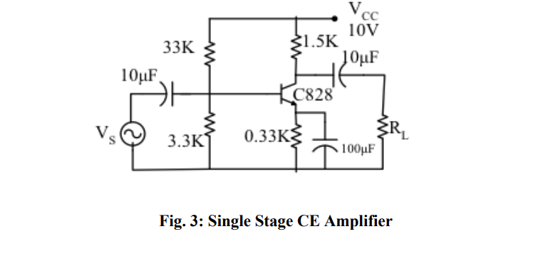

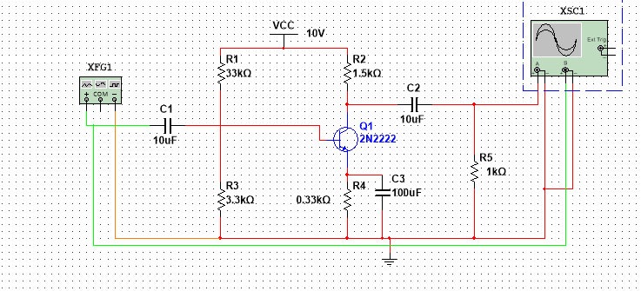

For Common emitter Configuration –
- Implement the circuit as shown in the figure -3.
- Feed different ac Signal input and observe the input and output on the CRO.
- From the Output curve calculate voltage gain.
- Then from the ac analysis of voltage vs frequency curve find the BW frequency.

For Common emitter Configuration –
- Construct the circuit as shown in Figure
- Apply ac input voltage for different frequencies and observe the output signals from the CRO.
- Measure the output voltage and compute the voltage gain.
- Measure bandwidth from ac analysis.

Data Analysis:

Simulations:

Common Emitter BJT
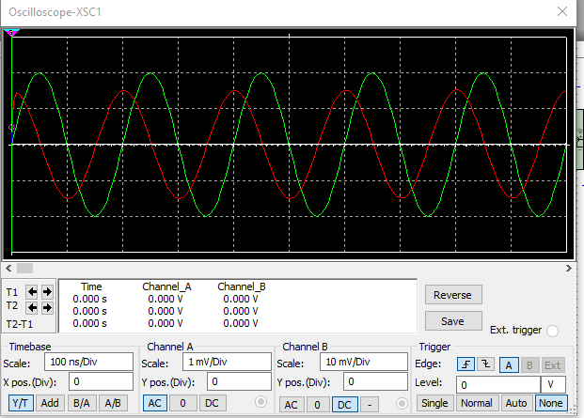
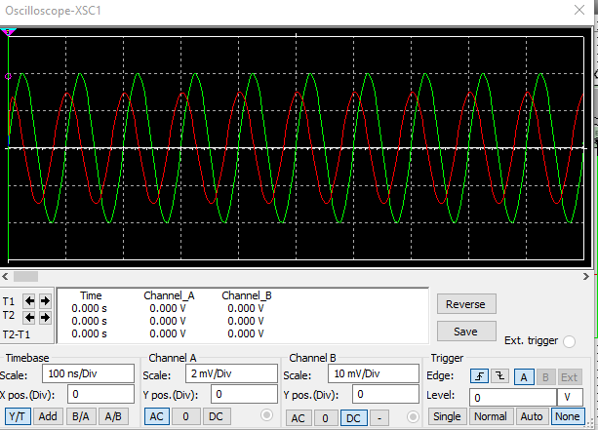
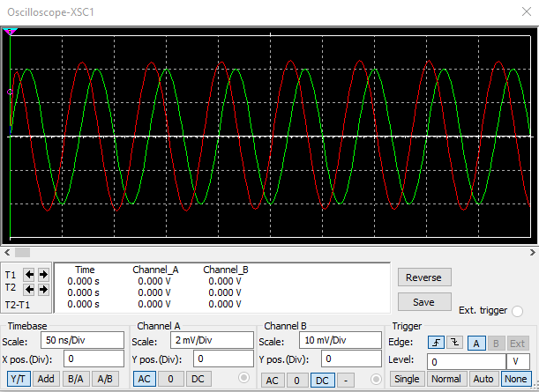
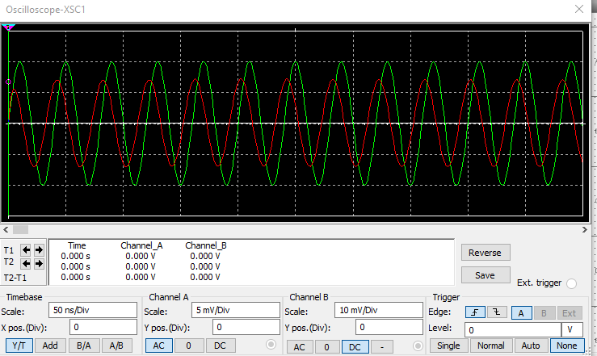

Common Source MOSFET

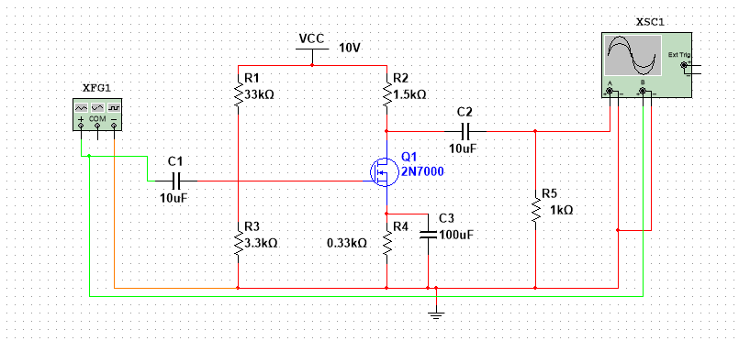
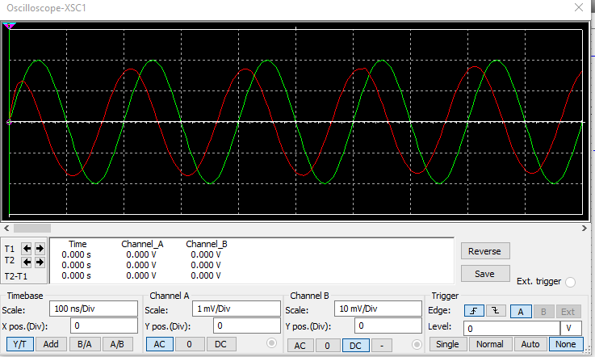
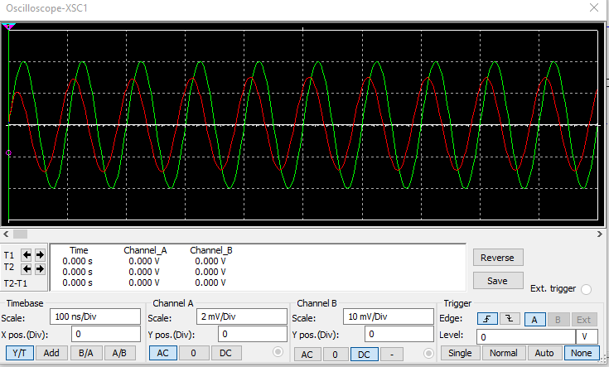
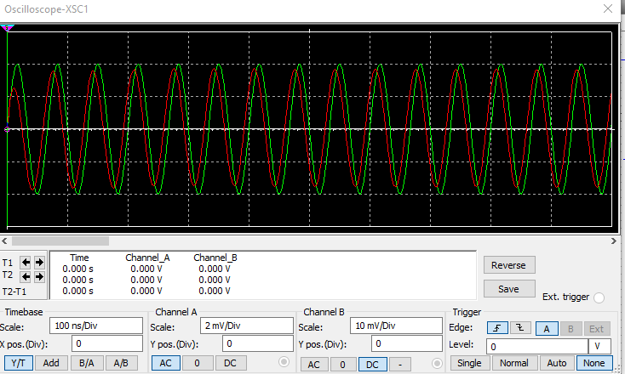

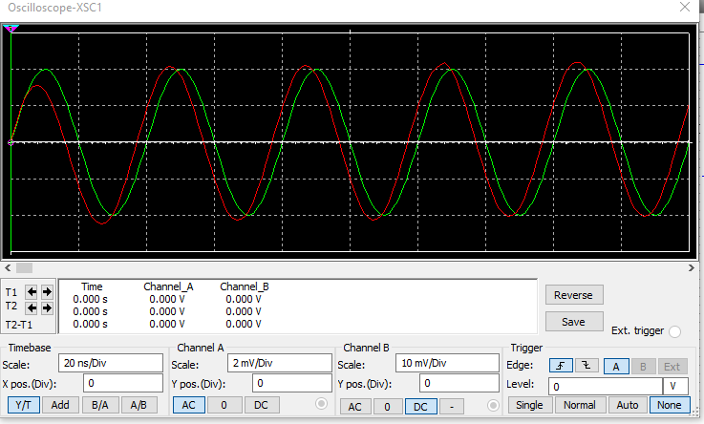
Data Table - 1:

For Common Emitter (CE) configuration for a BJT -

Serial No | Frequency | Input Voltage | Output Voltage | Voltage Gain | Voltage Gain in dB
1 | 100 HZ | 20 mv | 0.45 V | 22.5 | 27.04
2 | 500 HZ | 20 mv | 0.72 V | 36 | 31.12
3 | 1 KHZ | 20 mv | 0.84 V | 42 | 32.46
4 | 2 KHZ | 20 mv | 1.4 V | 70 | 36.90

Lower Cut-off Frequency: 103.08 Hz
Higher Cut-off Frequency: 26.422 MHz
Bandwidth, BW of CE BJT Amplifier: 26.422 MHz
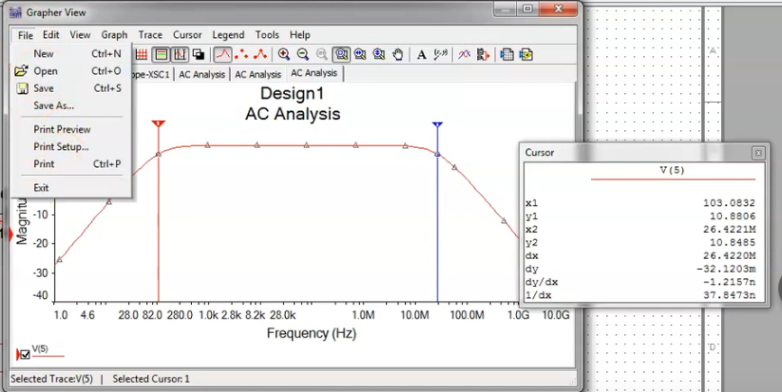

Data Table - 2:

For Common Source (CS) amplification for a MOSFET -

Serial No | Frequency | Input Voltage | Output Voltage | Voltage Gain | Voltage Gain in dB
1 | 100 HZ | 20 mv | 0.35 V | 17.5 | 28.64
2 | 500 HZ | 20 mv | 0.642 V | 32.1 | 30.13
3 | 1 KHZ | 20 mv | 0.76 V | 38 | 31.60
4 | 2 KHZ | 20 mv | 1.1 V | 55 | 34.80

Lower Cut-off Frequency: 40.60 HZ
Higher Cut-off Frequency: 5.06 MHz
Bandwidth, BW of CS MOSFET Amplifier: 5.06 MHZ

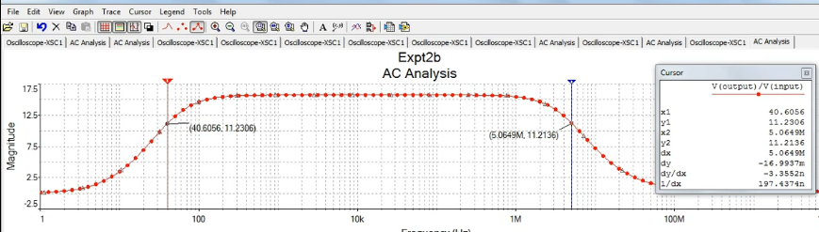

Discussion:

The dc power source needs to be switched off while changing the transistor. The trainer board needs to be checked if working properly. The circuit was connected properly and was also checked before taking the readings.

Conclusions:

- The dc power source needs to be switched off while changing the transistor. The trainer board needs to be checked if working properly. The circuit was connected properly and was also checked before taking the readings. In this way, we can measure maximum signal, voltage gain, bw of a frequency etc.

References:

1. American International University–Bangladesh (AIUB) Electronic Devices Lab Manual.
2. A.S. Sedra, K.C. Smith, “Microelectronic Circuits,” Oxford University Press (1998).
3. J. Keown, ORCAD PSpice and Circuit Analysis, Prentice Hall Press (2001).
4. P. Horowitz, W. Hill, “The Art of Electronics,” Cambridge University Press (1989).

